Bird Boxes – John Kubale 24-2-14

Shoalhaven Landcare have recently purchased 20 sets of 3 models of boxes for Microbats, Sugar Gliders and Parrots (medium size), for distribution around 10 Landcare groups in the Shoalhaven area. The boxes are intended to take the place of tree hollows that take up to 150 years to form in mature trees, the majority of which have been felled in this area.
Examples of the Microbat & Sugar glider boxes were shown at the Bengalee Landcare meeting at Tapitallee on the 2nd of February and I have put up three boxes as the photo below, and Garry Daly is also putting up another three for this group. We will monitor the usage of the boxes over the next year and report back.
The boxes come from an Adelaide company FauNature and the range of boxes, with descriptions and prices are shown on http://faunature.com.au/component/virtuemart/?page=shop.browse&category_id=2
The boxes are delivered in flat pack form in raw marine ply, with all fittings and assembly instructions requiring the user to work with a hammer and glue and an electric drill for pre-drilling the fixing points. It takes about an hour to assemble a box and then another ¼ hour/coat to paint the exterior with two coats of an acrylic paint, (not supplied). Garry Daly has also recommended pinning a panel of plastic on the roof to prevent deterioration from the weather.
We were able to bulk purchase at favourable prices and are prepared to place another order, with delivery to a central point (with pre-payment by the users), if there is sufficient interest to make it worthwhile, so please advise if you wish us to do so.
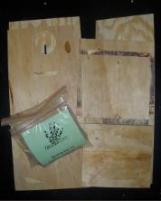
Flat pack for assembly
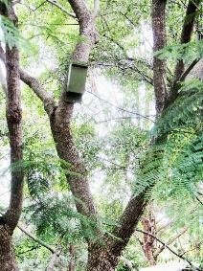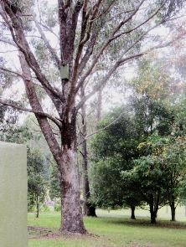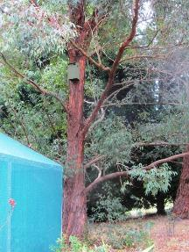
Microbat Sugar Glider Parrot –medium size

