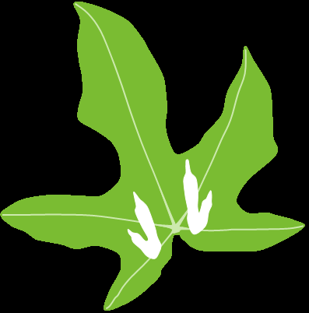

**Berry Corridor: from Escarpment to Sea**

** Vision**

* Sustainable and resilient vegetation connections
* supporting the movement of wildlife
* between the coast and the escarpment.

** Mission**

* To provide leadership, resources and information
* supporting the local community and stakeholders
* to achieve the vision.

** Objectives**

1. Document the present situation
2. Establish two-way Natural Resource Management (NRM) communications
   1. within local community and
   2. with stakeholders
3. Build NRM capacity of landholders
4. Support on-ground NRM works
5. Achieve the corridor

The current Berry Landcare work on achieving the corridor is through its Berry Bush Links Project, funded over a 10 year period through the Environmental Trust of New South Wales “Bush Connect” Programme. Our key partner is the National Parks Association of NSW and project officer David Rush.

**ENQUIRIES:** [berrylandcare@gmail.com](mailto:berrylandcare@gmail.com) or   
David Rush: 0418 977 402; [davidr@npansw.org.au](mailto:davidr@npansw.org.au)

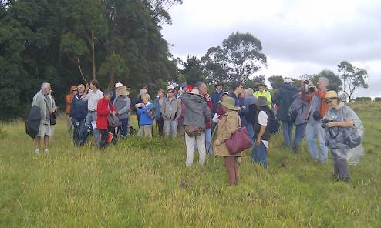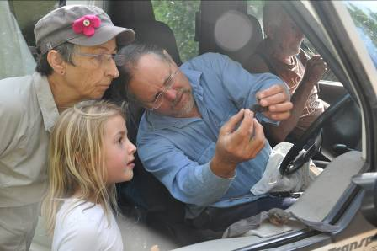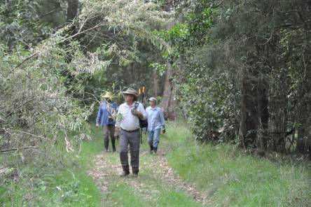

**About Berry Landcare**

Berry Landcare Inc. is a non-profit voluntary organization, with 10 work sites around Berry, incorporated as an association in December 2012 and an active member of the Shoalhaven Landcare Association and Landcare NSW; engaging the local community through a regular article in the monthly “Town Crier”, tree plantings, regular observance of national tree day and involvement of local schoolchildren in tree plantings, projects such as “Plant Local”, “The Berry Corridor”; Art Festivals, stalls at the annual Berry show and small farmers network field days and occasional talks to groups such as the local garden club and Rotary.

Berry Landcare has also actively worked with Fulton Hogan, contractors for the highway re-alignment to ameliorate the impact of the new road on the corridor and its wildlife. We believe we contributed to decision to landscape where possible with locally sourced, locally indigenous species and to the inclusion of tunnels and bridges that allow movement wildlife.

During its 15 years, Berry Landcare has received a number of grants, including two Southern Rivers CMA “Bush incentives” grants, an Envirofund grant, the “Berry Corridor Biodiversity Stepping Stones” grant from GER in 2013. There have also been devolved National Landcare Program grants though Shoalhaven Landcare Association, including in 2007 one for the establishment of an arboretum of locally indigenous trees in Mark radium Park and in 2012 one which among other things enabled the development of the management plan for the Berry corridor.

***Berry Bush Links Project: Extracts from Project Proposal***

*Berry Bush Links is a consortium comprising a Landcare group, over 50 private landholders, community and government organisations. These partners will work together to connect existing ‘stepping stone’ patches of native vegetation across tenures in the Berry Corridor of the Illawarra to Shoalhaven GER landscape via revegetation.*

*By controlling weeds and pest animals, this project will restore existing native habitat within the Berry Corridor to support a range of native wildlife including threatened species and endangered ecological communities.*

*Field days and community workshops focussing on seed collection, weed and native plant identification will be used to engage and motivate landholders.*

|  |  |  |  |
| --- | --- | --- | --- |
| **DSC00035** | **DSC05312** | **IMAG0243** |  |

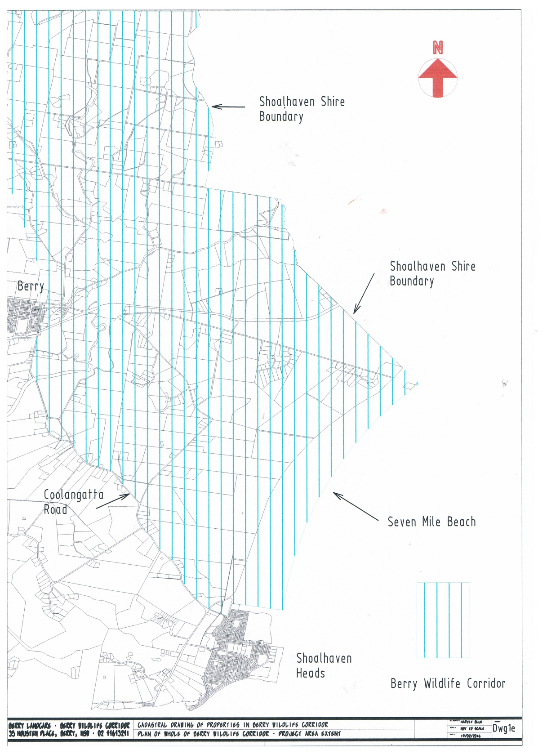

**Berry Bush Links Project**

Berry Landcare Inc. in partnership with National Parks Association of NSW recieved a grant of $500,000 over a 10 year period from the environmental Trust of NSW for the Berry Bush Links Project. With these funds we have available a project officer and funds for activities and on ground works.

The grant was announced at the end of 2015 with the project beginning to engage landowners in early 2016

**Objective 1: Increased participation of private landholders in on-ground conservation efforts in the Berry corridor area**

Minimum 50 private landholders engaged in on-ground conservation actions & coordinated with reserved lands for the life of the project.

* Development of a booklet outlining the importance of native vegetation and connectivity to native flora and fauna in the Berry area, a quarterly report on progress and significant events and attendance at regional events such as shows.
* Hold seven workshops designed to inform landholders about the project, the different levels of conservation commitment available and opportunities under the hotspots program.
* Hold seven field days designed to inform landholders about the importance of connectivity, demonstrate high quality native vegetation and corridors, best practice weed control and demonstrations of hotspot sites.
* Hold an annual landholder get together designed to increase landholder contact and mutual support and celebrate success.

**Objective 2: Increase protection and quality of existing native vegetation via weed control, pest management, fencing and conservation covenants**

A minimum of 20 patches of native vegetation >=5ha in size are protected by fencing, 150ha weed & pest animal control and 40 hectares protected by covenants on private land in the 15 km Berry corridor area, and approx 1700 hectares of public land are restored via weed & pest animal control:

* Weed control and appropriate followup is carried out in identified high priority native vegetation.
* Pest management carried out across a landscape-scale by project participants.
* Fences installed to protect remnant vegetation from grazing by stock.
* Conservation covenants in place over a minimum of three areas of private land.

**Objective 3: Increase habitat connectivity throughout the Berry corridor area via either linear connections or stepping stones**

A minimum of twelve hectares of native vegetation is established as either linking corridors or stepping stones during the life of the project, and corridors are a minimum of 20m wide:

* Seed collected from a minimum of 20 over and understorey species every year for five years using landholders, Conservation Volunteers and Green Army and a seed bank established.
* 2500 plants propagated per year for five years by volunteers, schools and landholders.
* 2400 plants planted on private land per year for six years.
* Fences are installed where required to protect revegetation.

   