Berry Landcare on Moeyan Hill: Saturday 19 December 2015
The Working Bee took us down to the creek and the rainforest section of the Reserve, after which we gathered at our place for the Berry Landcare "End of Year Barbecue", joined by others from our extraordinary local Landcare Community. Our Southeast Regional Landcare Facilitator (aka Peter Pigott ) manned the barbecue and Will Armitage, our Chairman, handed over the 2015 NSW Landcarer of the Year Award, which he had accepted on my behalf back in September at the NSW Landcare Forum in Orange.

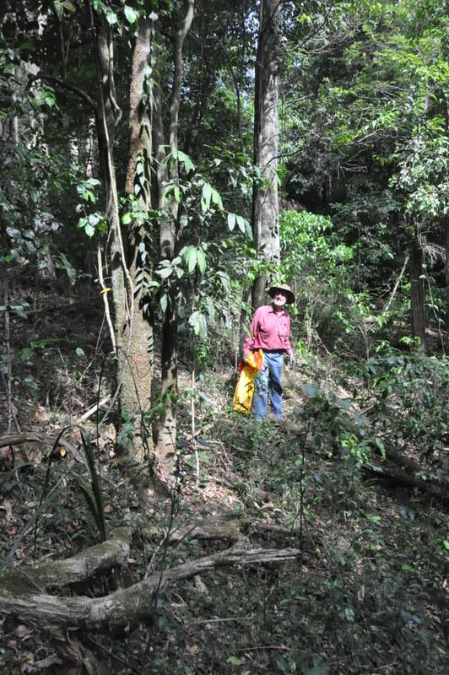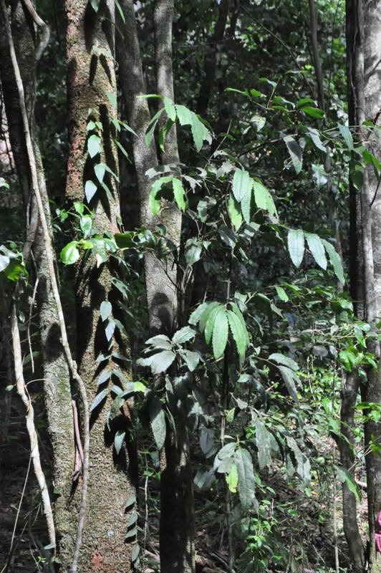
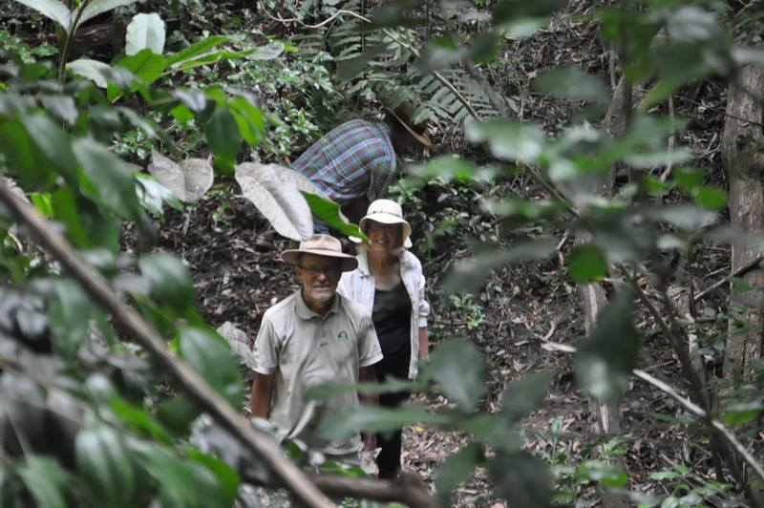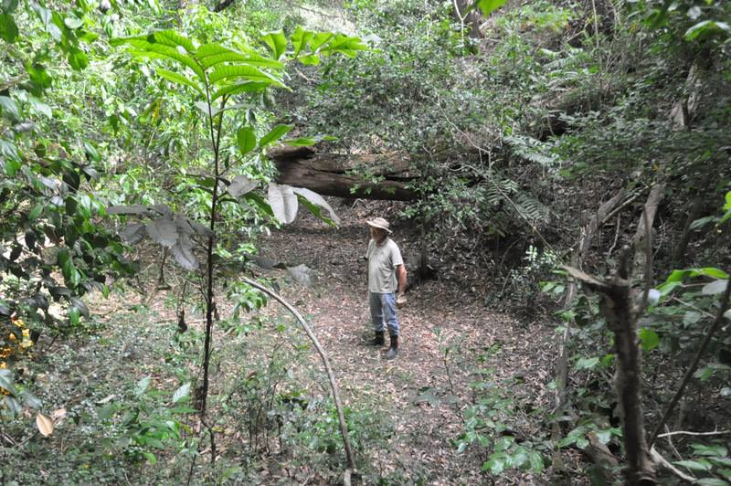
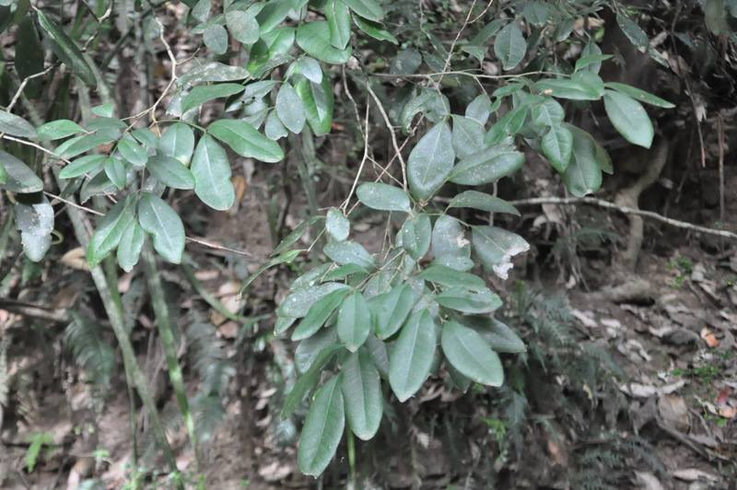
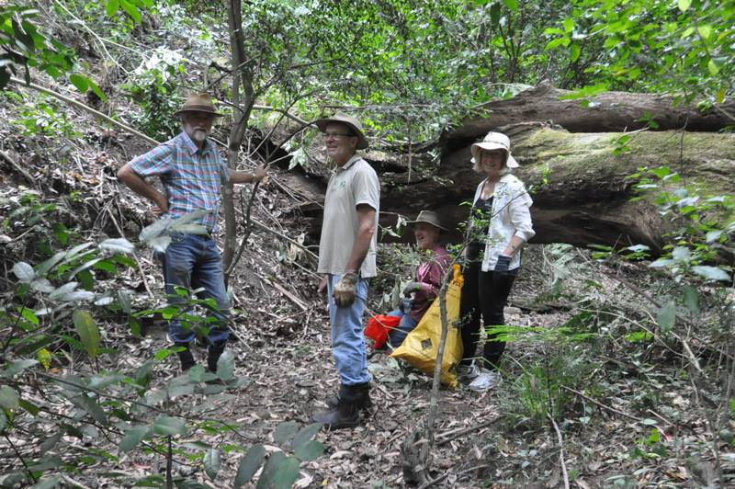
The working party for the day: We marvelled at the growth and the number of rainforest species that have grown up since the major lantana infestation was removed some seven years ago, and pulled weeds such as lantana, wild ginger, tobacco weed, camphor laurel, large leafed privet, small leaf privet and elephant ears, none of which belong in this rainforest remnant...
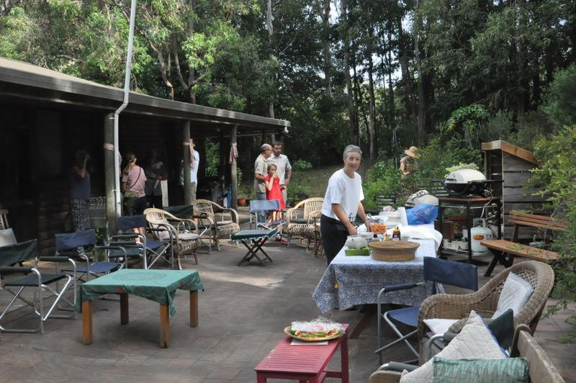
Preparing for the barbecue
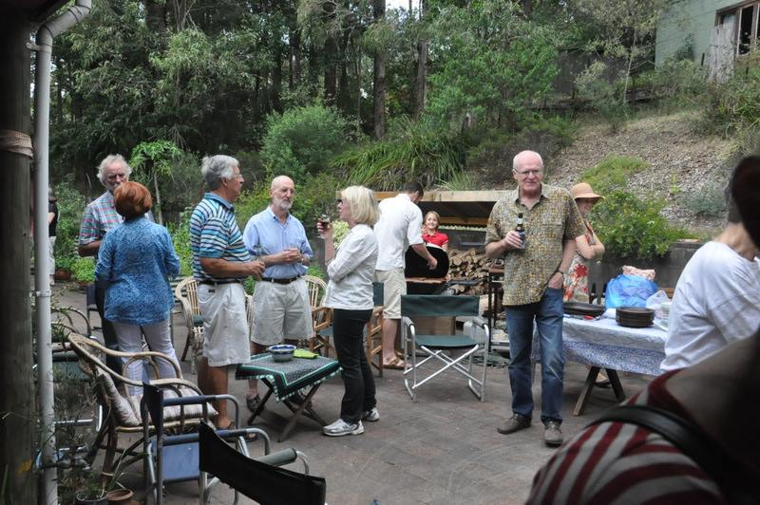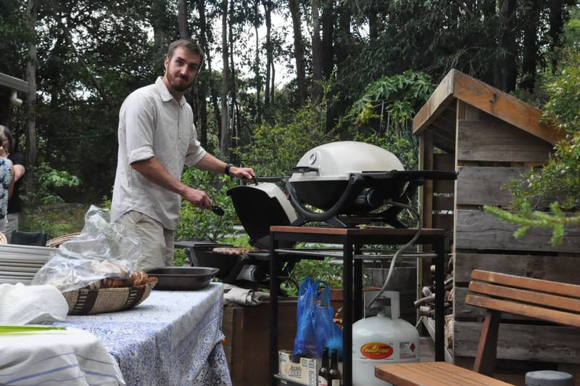
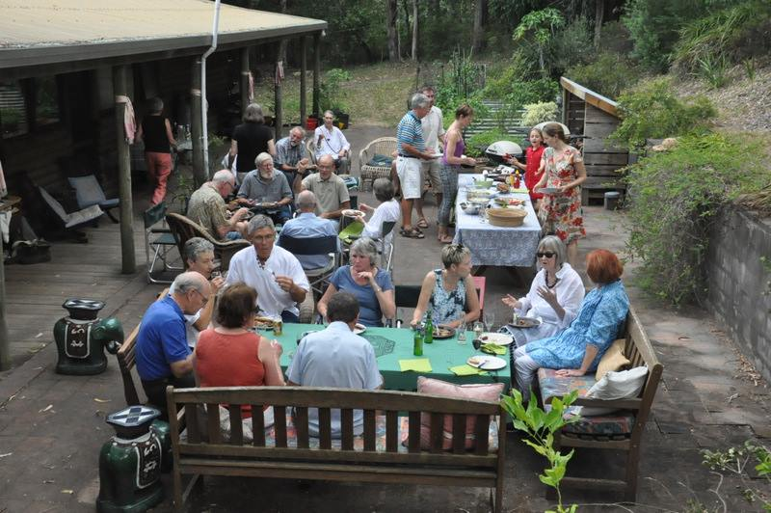
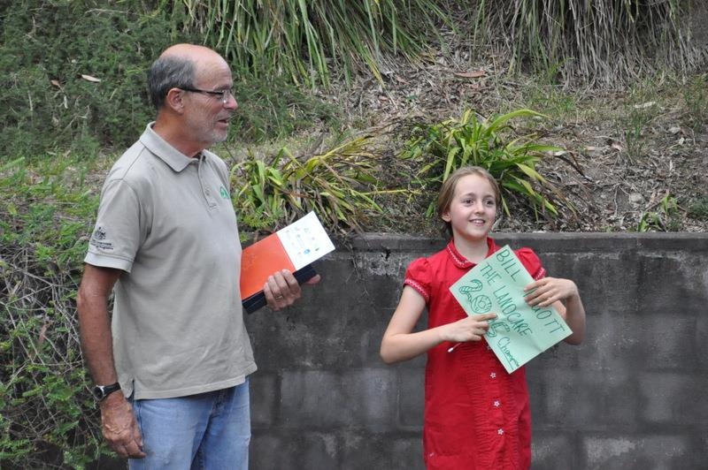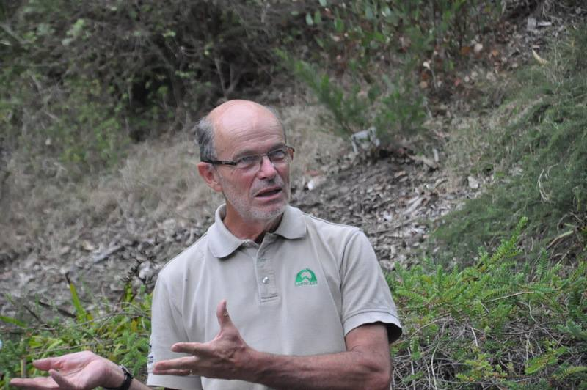
.. pays tribute to the wonderful Landcare Community we have here in Berry.
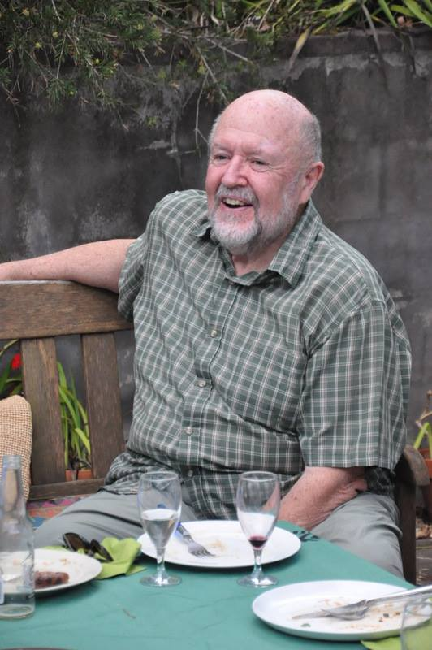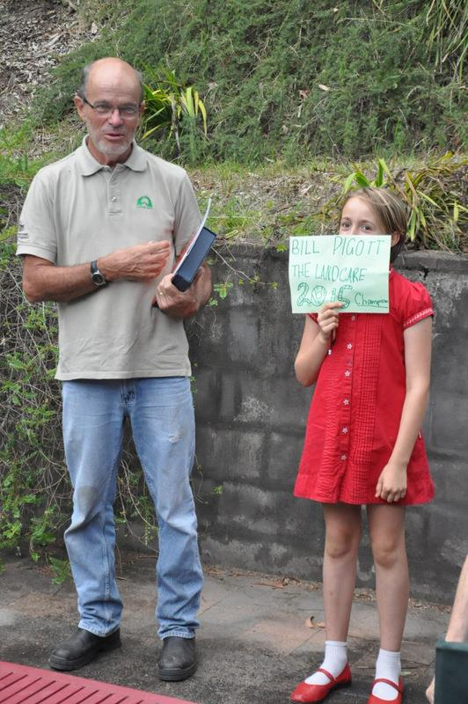
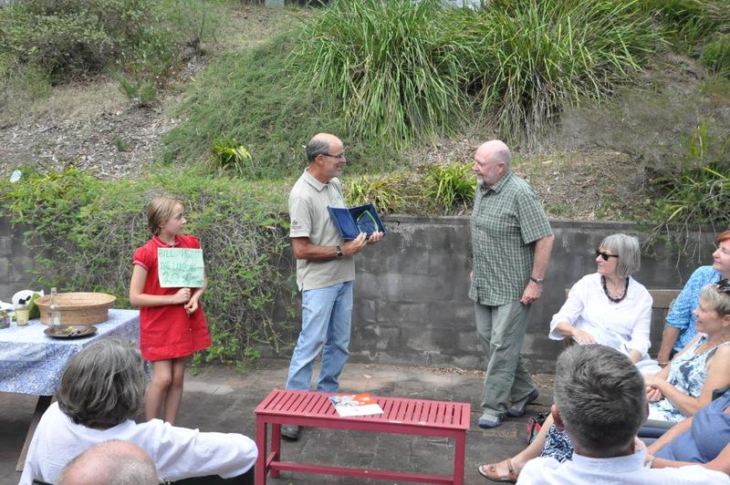
Handing over the award: Thank you Al Stratton and Will Armitage for nominating me.
Nothing is achieved without the efforts of many others, represented in this case by the gathering this evening. Thank you all for supporting and encouraging me.
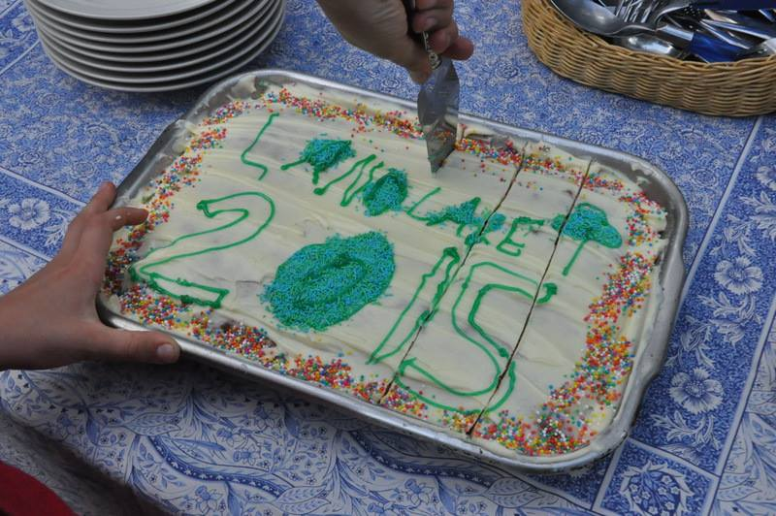
Leslie Pigott made one of her renowned carrot cakes (a Landcare tradition in these parts) and our special grand daughter iced it
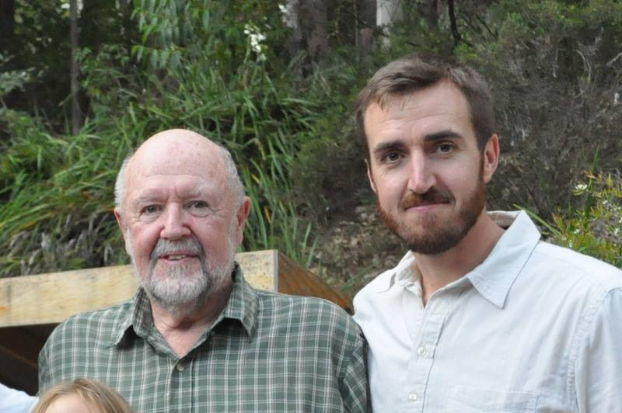
Landcarer of the year with the South East Regional Landcae Facilitator; two generations of Landcarer

