UTS ‘Big lift’ comes to Berry May 6 and 7 2017
The Big Lift team, 20 students from UTS, on what they refer to as a "Little Lift " doing big things in the Berry Corridor with Berry Landcare: Weeding and planting. Barbeque lunches on both days with beef from our Chairman’s cattle and other local produce. (And so great to have the use of Shoalhaven Landcare Association’s barbeque trailer). Saturday night curry by candlelight at a long table by the fire.
Amazing group of young people and some equally amazing Berry Landcare volunteers.
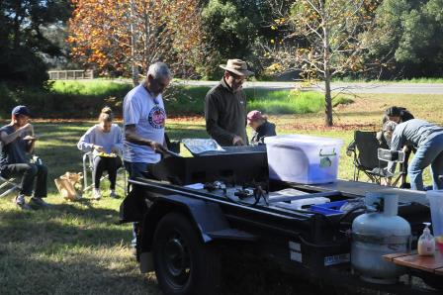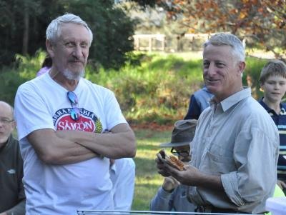
Jim Jefferis and Will Armitage at the SLA Barbeque trailer Jim Jefferis, Chair, Berry Landcare with David Rush
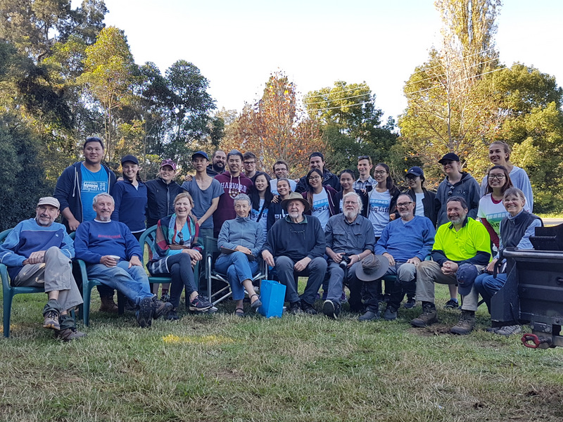
Group photo at the end of Day 2
