Berry Landcare

Junior Landcare:
Berry has a new Landcare Group. Berry Junior Landcare at Berry Public School is a group of kids who enjoy working and being in nature. This new initiative builds on the work done at the Berry School nursery to provide students with information on native plant propagation and care. As a first step they have created a wonderful website www.berryjuniorlandcare.com. Below is an extract from this website outlining what this new Landcare wants to achieve.
“Our group is just getting started, so now is a great time to get involved and help us to decide all the things we'd like to do together. Some ideas we have are to plant native bird gardens in our school, weed local creeks in our parks, grow and cook yummy food to eat, build insect hotels. Anything you can think of that will care for our environment.
At the moment, we are gathering in the afternoons at Berry PCYC School-Aged Care for working bees in our school Kitchen Garden. We also research together and draw pictures of nature.
In the future, we would like to meet in the garden and school hall with students, teachers, parents and community volunteers. We plan on visiting other schools and Landcare sites in the area to learn from their experiences and share what we know. We would like to have visits from experts in garden design, native plant propagation and native bee keeping.”
Berry Landcare is supporting this new group to achieve their aims. Intrepid Landcare, a group of young Landcarers based in the Illawarra who specialise in adventure based landcare activities, have also come on board to help inspire them.
If you want to be involved log onto the website to leave your contact details or contact berryjuniorlandcare@gmail.com.
National Tree Planting Day: This is on Sunday 31st July. We will gather at the Fulton Hogan work site on Woodhill Mountain Road at 10am and proceed to the Camp Quality work site. There will be a Bar-b-cue after the planting.

Weed and Native of the Month:
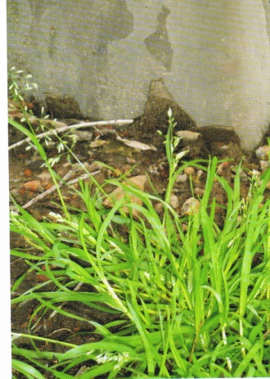Winter Grass 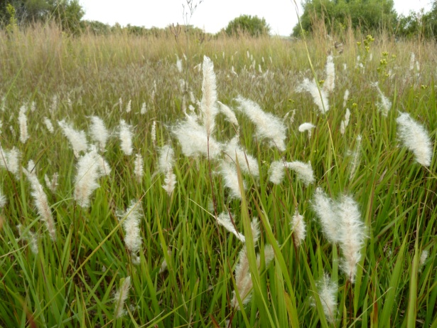 Blady Grass
Winter Grass: (Poa annua). Native to Europe. A small tufted annual grass with bright-green leaves, topped with a small panicle of seed heads to 15cm high. Seeds germinate from autumn to spring. With onset of hot weather plants die out. Seeds remain dormant until cool weather returns. To remove mow regularly before seed production.
Blady Grass: (Imperata cylindrical). A perennial grass native to Asia, India, Australia, and Africa. Height from 0.6–3 m. Leaves are about 2 cm wide near the base and narrow to a sharp point at the top; margins finely toothed and are embedded with sharp silica crystals. The main vein is a lighter colour than the rest of the leaf and tends to be nearer to one side of the leaf. Flower heads distinctive white “duster ‘ like. Considered an invasive weed by pastoralists.
These two plants illustrate the contextual aspect of the terms “Native” and “Weed”.

Working Bees for August 2016:
Alexandra Street Parkcare: 9-11 am Friday 19th August: Gail Paton 44487915.
Bong Bong Road: 9-11am Sunday 14th August: Julia Woinarski 4464 2084.
Bundewallah Bushcare: 2-4pm Sunday 28th August: John Clark 44643911.
Camp Quality: 9-11am Sunday 21st August: Jeanne Highland 4464 1271.
Moeyan Hill: 2-4 pm Saturday 20th August: Bill Pigott 44643241 or wpigott@bigpond.net.au.
Mount Coolangatta: 1-3 pm Saturday 20th August at end of Roxbrough Rd, Far Meadow.
Be on time to get a lift to site: Myke Cunningham 0418 297 435 or mcunningham@pci.cx.
Mark Radium Park: 9-10am Friday 26th August: Rodney Cole 4464 1475.
Princess Street Parkcare: Monday 22nd August from 9 - 11am, Terry Oades 4464.3651.
Tindalls Lane: 2-4pm Sunday 14^{h} August: Harvey Blue 4464 1880 or Jim Jefferis 4464 2988.
Plant identification service: Contact Harvey Blue 4464 1880 or Ian Parker, 4448 6359.
Visit our pages at: .landcare.nsw.gov.au/groups/berry-landcare for more on Berry Landcare and late changes to working bee details. Information can also be found on Facebook.

