Berry Landcare

Landcare Workshops and Community Activities:
Recent months have seen Berry Landcare working with the Berry Community in various ways. A landcare Workshop ‘From Seeds to Trees’ was held on 16th July at Berry Public School. Richard Scaborough from Landcare Illawarra and Lyn Clark of the Berry School Nursery talked about and demonstrated plant identification and seed collection. Many of the attendees were from outside the Berry area. The plants targeted were for use on local properties, farms and local revegetation sites.
National Tree Planting Day on 31st July demonstrated the Berry community willingness to support local environmental activities. On the Friday before NTPD students from 5th and 6th classes of Berry Public School along with Landcare volunteers and Fulton Hogan staff, planted trees in the designated area at Camp Quality on the North Side of Bundewallah Creek. This area had been prepared by Fulton Hogan for the Planting. The Council supplied guards, stakes, fertiliser tablets etc and have been working closely with Fulton Hogan, RMS and Berry Landcare to get the project off the ground. On the NTPD Sunday morning 63 people, young and old including employees of Fulton Hogan, planted trees and shrubs from Berry School Nursery and other local sources. These two work days resulted in the planting of some 460 plants. It was truly a magnificent result.

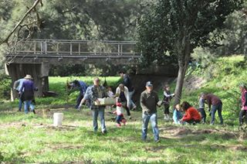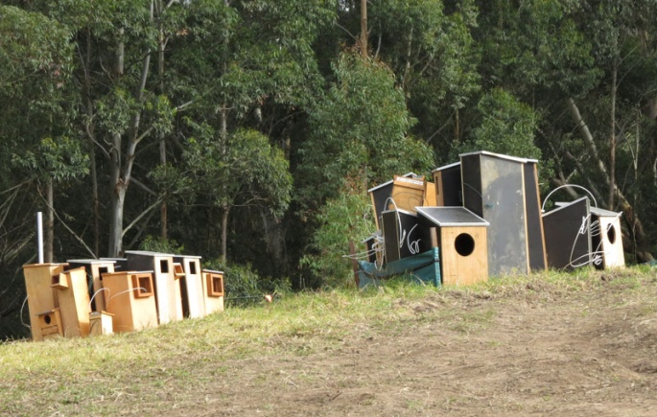
Workers at National Tree Planting Day Site. Fauna Nesting Boxes ready for Placement.
Fauna Nesting Boxes:
In a tree beside Bundewallah Creek above the NTPD planting site sits a nesting box. This is one of many artificial fauna nesting boxes placed in the areas around the new Highway alignment. This is being carried out by ‘NGH Environmental P/L’ a sub-contractor to Fulton Hogan. These boxes are of various sizes to suit a variety of animals. Two hectares of the forest area to the North East of Tindalls Lane in the Berry Wildlife Corridor has been removed for the highway. The remaining forest has had 43 boxes of varying sizes distributed in the trees. The fauna targeted include owl/owlet, king parrot, dollarbird, cockatoo, kingfisher, possums, sugar/squirrel gliders and antechinus. One is a double chamber Micro bat box in case there are pregnant females – apparently the males scout around first to find maternity type hollows & then the pregnant females take up residence the next year. Ecologists will check the boxes twice a year for the next 5 years to assess usage and will adapt the designs to encourage more use & optimise placement.

The Bundewallah Sub-Tropical Rainforest Regeneration Project
The Bundewallah Bushcare group has been working on Bush regeneration since 2006. A fact sheet has been compiled about this work that covers a range of extremely helpful topics for anyone interested in bush regeneration. For further information contact Shoalhaven Council’s Bushcare Coordinator, Alasdair Stratton (02 4429 3592) or bushcare@shoalhaven.nsw.gov.au.

Working Bees for September 2016:
Alexandra Street Parkcare: 9-11 am Friday 16th September: Gail Paton 44487915.
Broughton Vale: 2-4 pm Sunday 4th September: Barry Virtue 44641389.
Bong Bong Road: 9-11am Sunday 11th September: Julia Woinarski 4464 2084.
Bundewallah Bushcare: 2-4pm Sunday 25th September: John Clark 44643911.
Camp Quality: 9-11am Sunday 18th September: Hugh Sheil hugh.sheil@realtimecom.com.au or Jeanne Highland 4464 1271.
David Berry Hospital: 2-4pm Saturday 17th September: Leslie Pigott 44643241.
Mount Coolangatta: 1-3 pm Saturday 17th September at end of Roxbrough Rd, Far Meadow.
Be on time to get a lift to site: Myke Cunningham 0418 297 435 or mcunningham@pci.cx.
Mark Radium Park: 9-10am Friday 23th September: Rodney Cole 4464 1475.
Tindalls Lane: 2-4pm Sunday 11th September: Harvey Blue 4464 1880 or Jim Jefferis 4464 2988.
Information can also be found at Berry Landcare on Facebook.
Plant identification service: Please contact Harvey Blue 4464 1880 or Ian Parker, 4448 6359.
Visit our pages at: http://www.landcare.nsw.gov.au/groups/berry-landcare for more on Berry Landcare and late changes to working bee details. Information can also be found on Facebook.

