Bowning & Bookham Districts Landcare Group

Box Woodlands Workshop
A Saving Box Woodlands workshop was held at the Bookham Memorial Hall on May 10th. The workshop included the following speakers:
- Alan Cole who spoke on rural tree decline and the Bowning & Bookham Districts Landcare Group’s Bjarne K Dahl Trust Eucalyptus revegetation program.
- Catherine Ross from Greening Australia who outlined options to regenerate Box Woodlands.
- Mason Crane from ANU Fenner School who discussed the ecological significance of the Yellow Box Blakeley’s Red Gum as well as the value of the vegetative community fauna survival.

Lots of detailed information was discussed and great pictures of Box Gum woodland plants were shown to the good turn out of people. Thanks in particular go to the Bookham Memorial Hall Committee for providing lunch and morning tea.

After the workshop the group did a walk through the Bookham Cemetery and encountered a group of illegal wood collectors. The Landcare group approached the Yass Valley Council after the incident. The Council moved very swiftly and installed signs on the three entrances to the Cemetery advising of the important ecological nature of the site and that wood removal was not permitted.

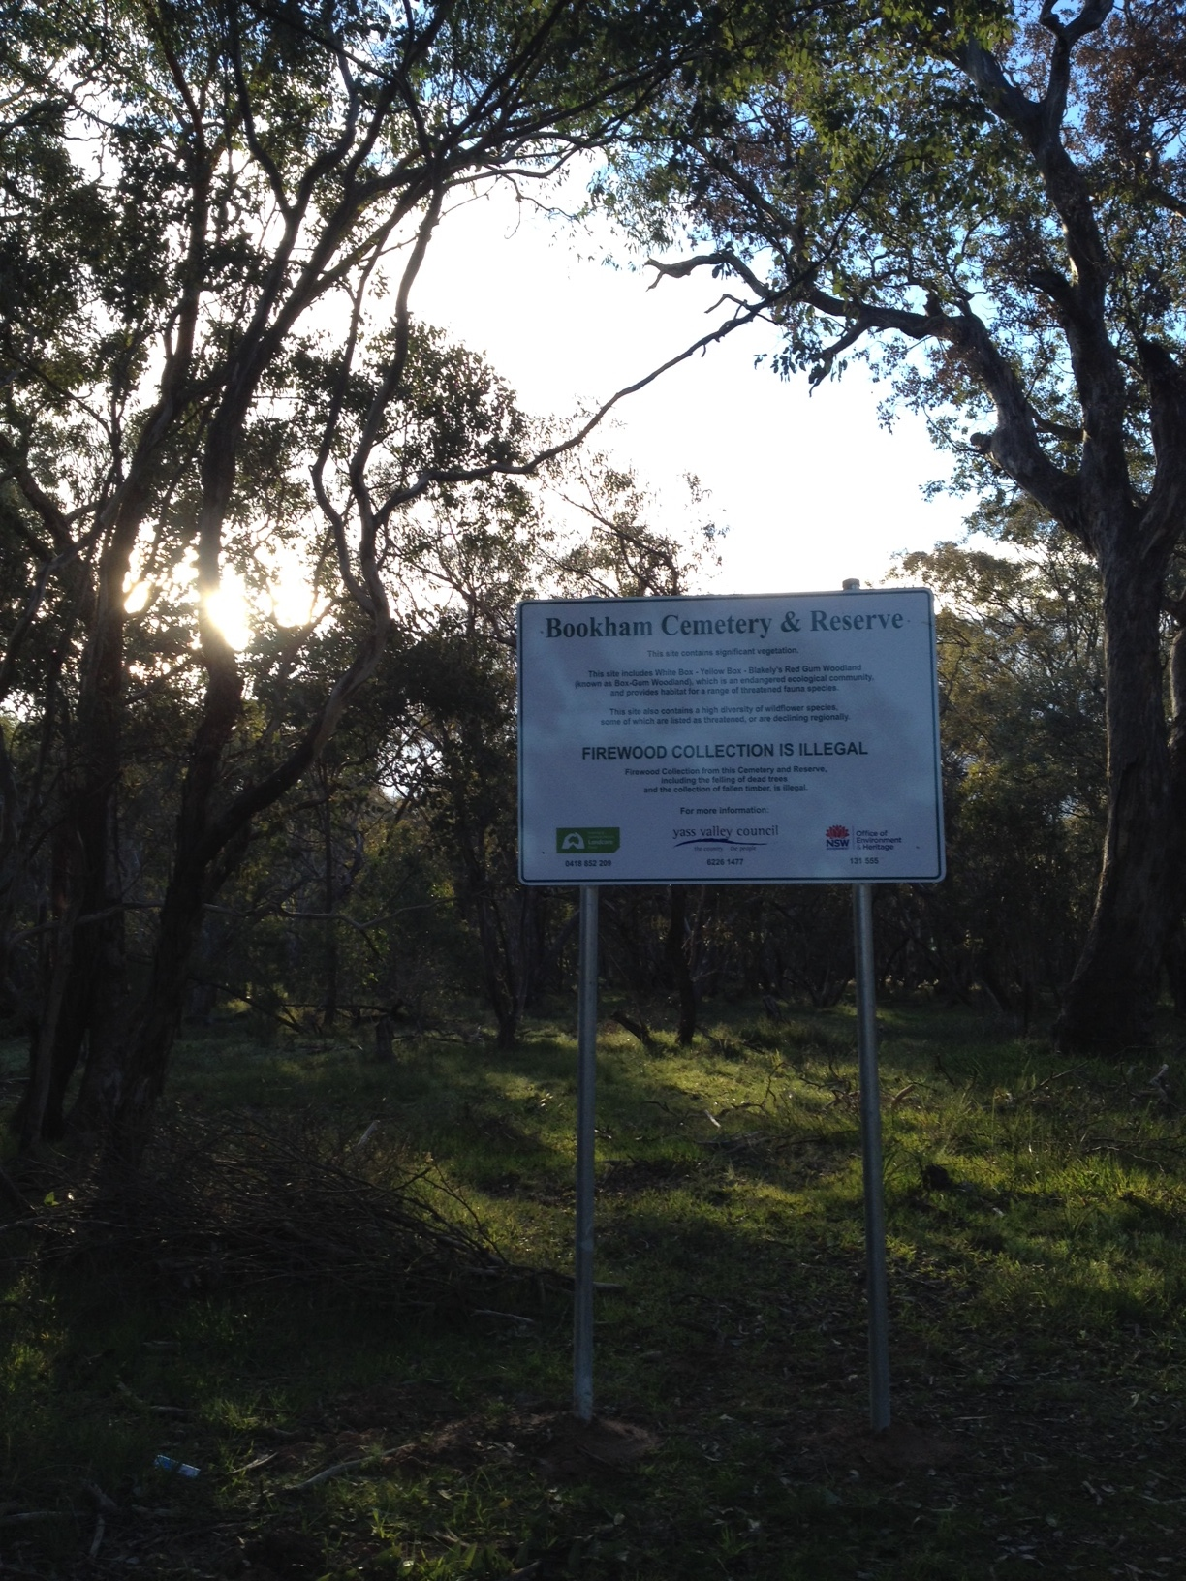

Seed Workshop
The Bookham Memorial Hall was also the venue of the Bowning & Bookham Districts Landcare Group’s Seed Collection and Storage workshop on May26th. Martin Driver of PlainSense Vegetation Management led the workshop. Martin provided a comprehensive booklet titled Direct Seeding Landholder Training Manual by the Murrumbidgee Catchment Management Authority to participants.
Property Visit
The Bowning & Bookham Districts Landcare Group visited Gary and Hansie Armour’s property in Childowla Road Bookham on July 26th to have a look at the work the owners had done to propagate Boorowa Mix seeds as wind breaks and to support native birdlife. The large group of members and visitors were impressed that the direct-seeded areas had grown to three or four metres in height after only a few years. Gary was of the opinion that direct seeding had worked better for tree propagation than previous attempts with seedlings.

Bjarne K Dahl Trust
The Bowning & Bookham Districts Landcare Group has won a grant from the Bjarne K Dahl Eucalyptus Trust and has used the funds for propagation of 10,000 Eucalyptus seedlings, primarily intended to help landowners affected by the January 2013 Childowla Road fire. So far, 5000 trees are have been delivered or committed to Bookham bushfire affected landholders; the rest of the trees are still growing well at the Transgrid Nursery and have not been adversely impacted by frost to-date.

Landowners interested in growing Eucalyptus on their properties can contact Kathy McGuirk the Secretary of the Group on 0428 822854 or email at kangiara@gmail.com.au. Priority will go to fire affected properties, but others interested in growing the trees as a sustainability measure are also invited to take trees for their property.

The Group is keen to grow on more trees in Spring 2014 at the Transgrid site. In addition to Eucalyptus, the Group is looking to propagate understory plants. The group will also consider propagating deciduous plants and fire-resistant plants if members were interested and could provide seed. They have started collecting Kurrajong seed (one of the main fire-resistant native trees), but fire-resistant shrubs / trees such as Bent leaf Hickory, Blackwood, Silver , Kurrajong, River She Oak, White Cedar, and Lilly Pilli, along with introduced fire-resistant plants such as Maple, Sweetgum, Plane Tree, Poplar, Holly , Oaks and Elms will be considered.

So members and visitors are invited to the next seedling propagation day, which will be held at Transgrid in Yass on Saturday October 25th from 9am. Bring a hat, gloves and some water along with something for morning tea. Greening Australia ACT will be providing the native seed for Eucalyptus and shrubs however if members wish to also propagate deciduous trees or specific fire resistant species please bring seed to this event.

Landowners who have received seedlings from the Group are requested to return the tubes and crates to enable another bulk seeding in October 2014. Any donations of pots etc will also be most appreciated - please contact Kathy McGuirk.

Yass Landcare Soil Biology Workshop, September 14th
David Hardwick, an excellent educator and expert in ecological agriculture, will lead an interactive workshop on soil biology on September 14th. The workshop will be a practical, hands-on day learning about soil health and how to assess your soils using the Landcare Rapid Assessment of Soil Health system.

This workshop will take place on Roger Buckman's property: 822 Good Hope Road, Yass, on Sunday 14 September. Morning tea and lunch provided.
Cost: $25.00. Places are limited so please register with Jill McGovern, 0450 960 215. Email: wineshed@optusnet.com.au. This workshop is hosted by Yass Landcare Group and sponsored by the Australian Government through South East Local Land Services and the Regional Landcare Facilitator project.

Meetings
The Bowning & Bookham Districts Landcare Group holds its relaxed and informal meetings on the third Thursday of the month at either the Bowning Hotel or Barney’s of Bookham. The meetings start with dinner at 6:30pm and the meeting kicks off at 7:15. All welcome. The next meeting will be the Group’s Annual General Meeting and will be held at the Bowning Pub. See you there.

