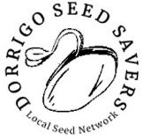

NEWSLETTER
DECEMBER 2019
FIRE & WATER P1 | FUTURE-PROOFING P2| NEWS & ACTIVITIES P3| OUR COMMUNITY P4
FIRE & WATER
Ancient islands of Gondwana old growth forest have been burning in this catastrophic fire season on the Plateau, and more than two million hectares of NSW native forests have gone up in flames.
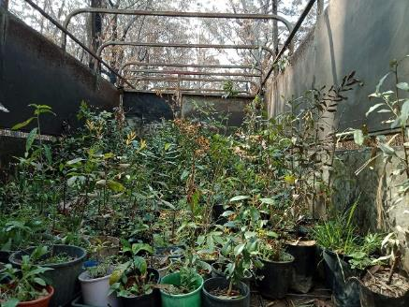
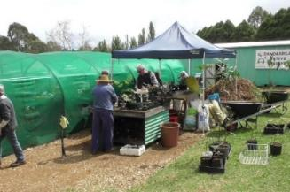
At Billy’s Ck, Barry Hicks lost most of his forest to the flames in September, while fighting fires to protect other properties.
Miraculously, his caravan and shade tunnels survived the destruction, but with no available water, a rescue was urgently needed.
Thanks to the generous response from our community of volunteers, two cattle truck-loads of fire survivors (over 3,300 trees), were relocated to the Dandarrga Landcare nursery in Dorrigo. 129 different species arrived in melted pots with singed leaves.
Teams of volunteers set to work in October, in smoky conditions & with fires still burning, to re-pot, revive, identify & care for these trees. Another shade house was renovated, and more irrigation installed. These trees are now thriving, ready to plant.
Photo by Rhona Verrall

COLLECTING RAIN
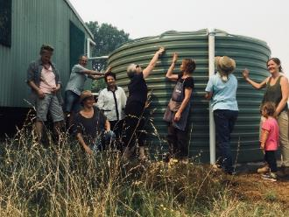
As the drought continues, and with the expansion of the Nursery, we are installing a rainwater irrigation system. The first stage is the new tank, and a pressure pump. Stage two will add new pipe and sprinklers, and an automatic controller.
We are very grateful to our community for support, sales, and for the many donations on the GoFundMe organised by Bellinger Landcare.
See Page 4 Our Community
Our new tank

FUTURE-PROOFING with LOCAL TREES
Trees are essential to the water cycle, they bring rain, store carbon and breathe out fresh air. In 2019, a growing number of local landowners have been active, planting trees. Trees improve soil, provide habitat and shade, control weeds, retard fire and protect waterways. Plant a tree - there are so many benefits!

Hands-on Tree Planting, Weeding and Watering is ongoing on four sites, at the Bielsdown River below the medical centre, on Rocky Ck outside town, on Deep Ck
in town, and above the Blicks River at Dundurrabin, near the Community Centre.

All are welcome to become involved in our activities, which include Rainforest Species Identification Site Visits to private land or National Parks, and free Friday ID sessions at the nursery. We also do Site Consultations on private land.

Our Native Seed Calendar is a work in progress. We email a bi-monthly seed calendar summary to interested members. If you would like to help document seeding and flowering times, and collect or donate seed, please email dandarrga@gmail.com

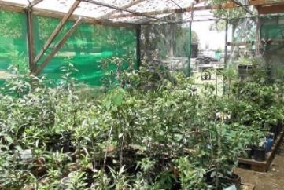
We have a range of Fire-Resistant Native Plants for sale - what to plant around your home, or along forest edges, for some protection from embers.
CLICK HERE or visit our website

We work with Bellingen Landcare, who have an Expression of Interest form on their website for those in Bellingen Shire, in order to apply for grants.
* Rainforest and pioneer tree, shrub, orchid and grass species in hicos, tubes and pots.
Click HERE for Natives Stock list or visit our website.
(Trees also for sale at Dorrigo Rainforest Centre)
* Vegetable, herb and flower seedlings and seed
(Seed is also on sale at Dorrigo Library)
* Food tree species, including bush tucker trees
* Tree guards, mulch, compost, worm castings and worm juice
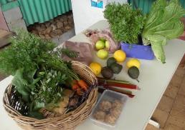
* Recycled timber, roofing iron and useful bits and pieces

Free local garden produce on Fridays and free books
and magazines on natives and gardening in general.

SURVEY of OUR MEMBERS
Attached is a survey to give us more feedback from you, our members. If you are interested, please fill it in and email it back, or bring it into the nursery. Thanks!

The DORRIGO SEED SAVERS
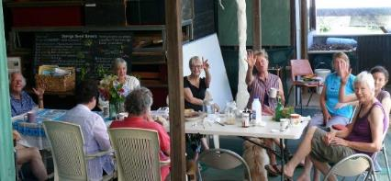
Our range of non-hybrid and heritage seeds are grown by Dorrigo gardeners, and collected, processed and packeted at Dandarrga Nursery. They include vegetable, herb and flower species.
Come along on Wednesdays at 10am to join us and learn how to save, store and process your garden seed. We have dedicated seed garden beds, and community gardens at the nursery, and we welcome volunteers who love growing food and useful plants.
SUMMER SEED to COLLECT: Broccoli, Cabbage, Zucchini, Beetroot

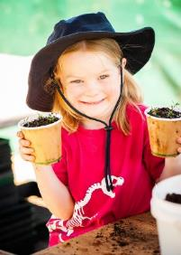
FOLK & BLUEGRASS FESTIVAL 2019
Our stall at the Folk and Bluegrass Festival did record business selling native plants and food seed. A kids’ workshop on composting paper and propagating seedlings was well attended by festival goers, with everyone participating in building a compost heap. The kids took away a gift paper cup with local River Tea Tree seedlings they planted themselves.

FESTIVAL COMPOSTING
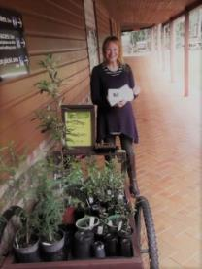
Food waste, paper cups, plates and bamboo forks from 3,000 or more Festival visitors were delivered to the nursery as agreed. With an early start, several volunteers coordinated the chipping, safe storing, burying and initial composting of the total load before midday!

THE RAINFOREST BARROW
We’ve been selling trees from our Barrow at the entrance to the Dorrigo Rainforest Centre. Big thanks to George and the staff at the RF Centre, to Eleanor for weekly visits, to Rick for emergency welding when the wheel fell off, and to all who helped make this a success.

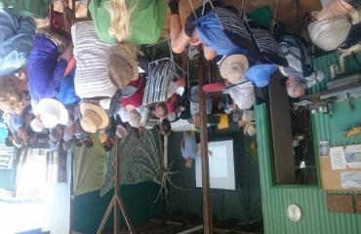
FIRES and FOREST ECOLOGY
Ross Macleay gave a timely presentation on our Plateau Forest Ecology and Fire to an attentive audience at Dandarrga Nursery on 9th November.
The talk was organised by Bellinger Landcare for their AGM. The event was a great success, and a chance for like-minded people from a wide area to discuss our current fire and forest crisis.

DANDARRGA NURSERY  OPENING HOURS  Mon, Wed, Fri & Sat  9:00 am – 12:30  DANDARRGA LANDCARE on NSW Gateway  DANDARRGA LANDCARE on FACEBOOK  OUR YOUTUBE CHANNEL  DORRIGO SEED SAVERS & AWARENESS GARDEN  on FACEBOOK  CONTACT:  PH: 02 6657 1189  EMAIL:  dandarrga@gmail.com  LOOK FOR US at  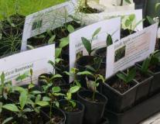  MID Markets  Bello Plant Fairs  Dorrigo Community Market  Dundurrabin Coffee and More Market  DOWNLOAD A MEMBERSHIP FORM | OUR GENEROUS COMMUNITY  Thank you for all the ways people have helped and supported us in 2019. We are glad to be working with Dorrigo Recreation Management Committee (Showground Trust), Dorrigo Chamber of Commerce, Mountain Top Landcare, Clarence Landcare Inc, Bellingen Landcare Inc, Dorrigo Folk and Bluegrass Festival Committee, Dorrigo Preschool, Dorrigo High School, Dorrigo Youth Hub, Dundurrabin Community Centre, U3A, Bellingen Shire Council, Dorrigo Library, Arts Council of Dorrigo, Dorrigo Local Aboriginal Land Council.  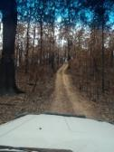  Thanks to all volunteers at both ends of the Blue Rock Road fire rescue mission, and Steve Berlitz the truckie. Thanks to Bill Peel for helping with ID, and everyone who helped repot, re-home and water Barry’s trees.  Special thanks to Sandy Eager at Bello Landcare for grant applications and the GoFundMe campaign - Growing trees for Dorrigo Rainforest recovery, which is helping to fund our new rainwater irrigation system.  Big thanks to Les Bravery for the chipper and his help with the Paper Composting after the Folk and Bluegrass festival.  We appreciate Pete Murphy for his ongoing tree planting and watering at Bielsdown River and Deep Ck. Regen projects.  Many thanks to everyone who donated to our Pump Fund at the local markets. We will be using the new pump on our regen projects this summer!  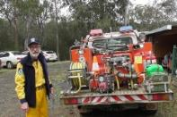  We donated trees to the value of $100 to the Tyringham RFS Fundraiser at Dundurrabin. We are so grateful for the local fireys and their support teams, and for the volunteers feeding wildlife, and the small teams putting out fires in our Gondwana rainforests.  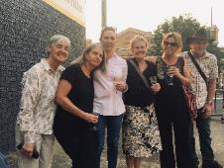  Thank you to Kate O’Leary at Ray White Real Estate, and to all our financial supporters this year.  With generous donations of time, labour, seeds, plants, books, tools, skills and materials from friends, customers, our members, and our wonderful core team of volunteers, Dandarrga Landcare and Dorrigo Seed Savers have had a busy and rewarding 2019.

Dandarrga Survey Form

Name: __________________________________________________

Location: ________________________________________________

Please tick anything that you would like to be involved with:

◻ Weed management ◻ seed propagating

◻ regular landcare ◻ seed collection calender

◻ regenerating local parks ◻ seed collecting

◻ community liaison ◻ seed available on your property

◻ working bees ◻ research

◻ the management group ◻ subcommittees (eg maintenance)

◻ newsletter production ◻ dealing with correspondence

◻ general office support ◻ markets

◻ food foraging ◻ council liaison

◻ fund raising ◻ photography

◻ representing the organisation ◻ cataloguing books

◻ posters ◻ filming and editing

◻ events ◻ species list, write ups

◻ grant applications ◻ Dorrigo Seed Savers

◻ inducting and supporting new and current members

◻ ute/trailer available? Manage/help collection of mulch, sand, compost

Have we missed anything that interests you?

◻

◻

◻

◻ Would you like help with Landcare on your property? We offer group volunteer support in exchange for hours that you volunteer, or useful material that is donated to our projects.

Please fill in Dandarrga Landcare Expression of Interest form
if you would like to take part in any of the above activities.
Thanks!

Dandarrga Volunteer Expression of Interest

We’d like to know a bit more about your interests so that we can keep you informed about relevant issues, and provide you with opportunities to participate.

Name:

Phone:

Email:

Projects or Events that I would like to take part in (tick your choice)

◻ Dandarrga Landcare Nursery

◻ Bush regeneration

◻ Tree planting days

◻ Plant ID sessions and excursions

◻ Seed collecting

◻ Other (eg. Admin or PR)

◻ contact me now ◻ contact me in a few months ◻ contact me next year

I have experience in:

I have skills in:

My strengths are:

Do you have a disability or medical condition which may affect your ability to do certain types of work that we need to know about?
◻ Yes ◻ No

DANDARRGA LANDCARE & DORRIGO SEED SAVERS DECEMBER NEWS 2019

