[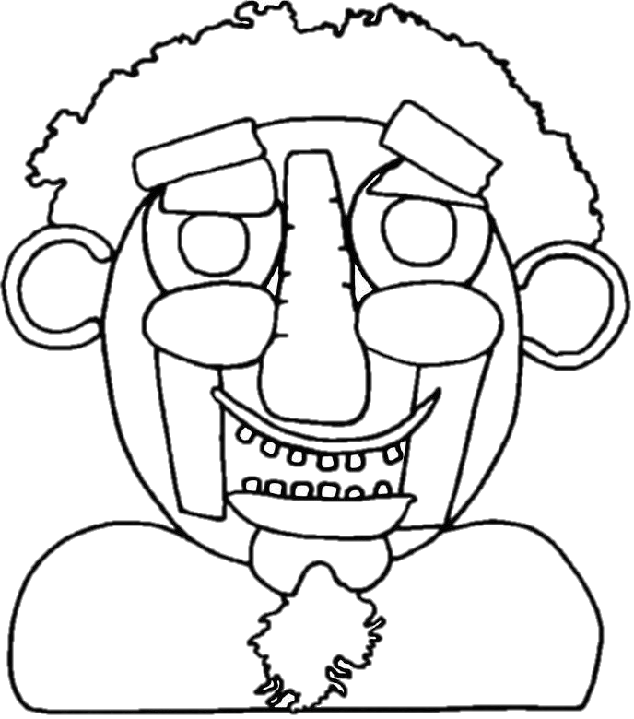](http://www.childrensweekwa.org.au/library/file/FunStuff/2and5_VegMan_ColourIn.pdf)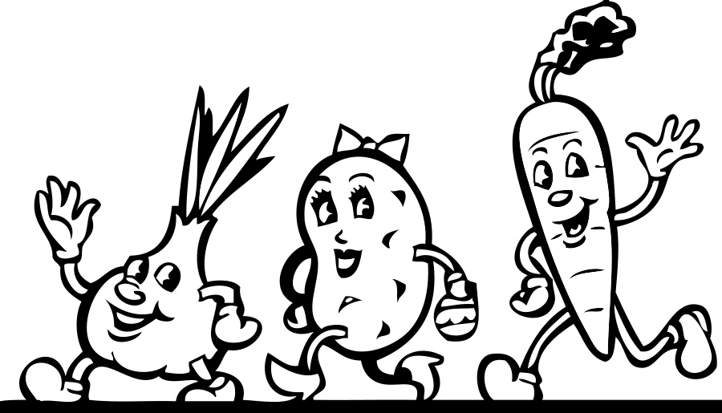

It’s not rude if your food’s NUDE