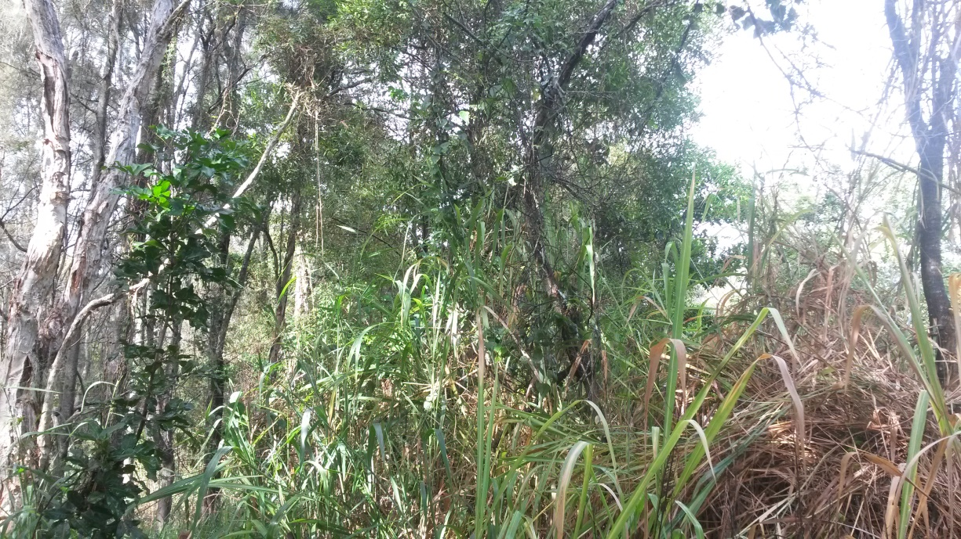
Photo point 1 (looking East) April 2014

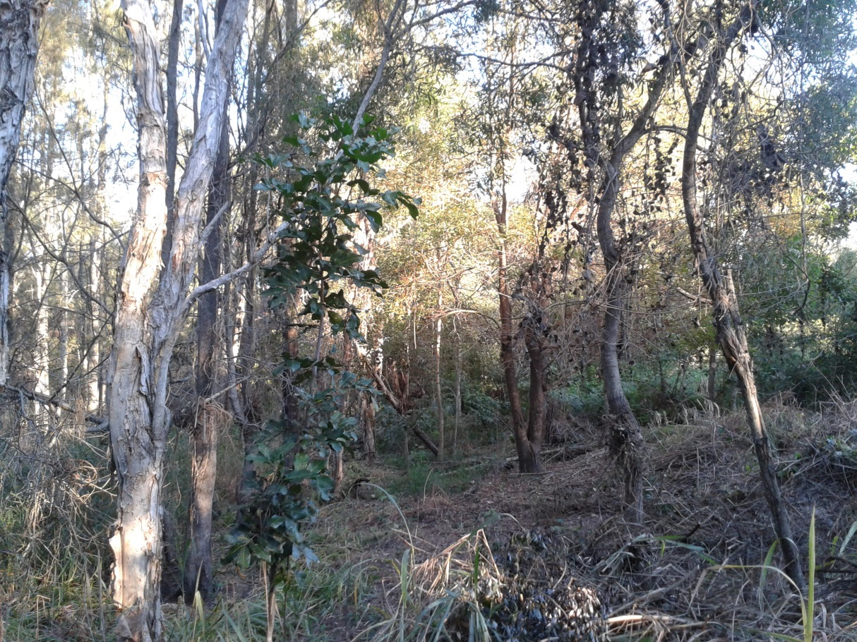
Photo point 1 (looking East) May 2014

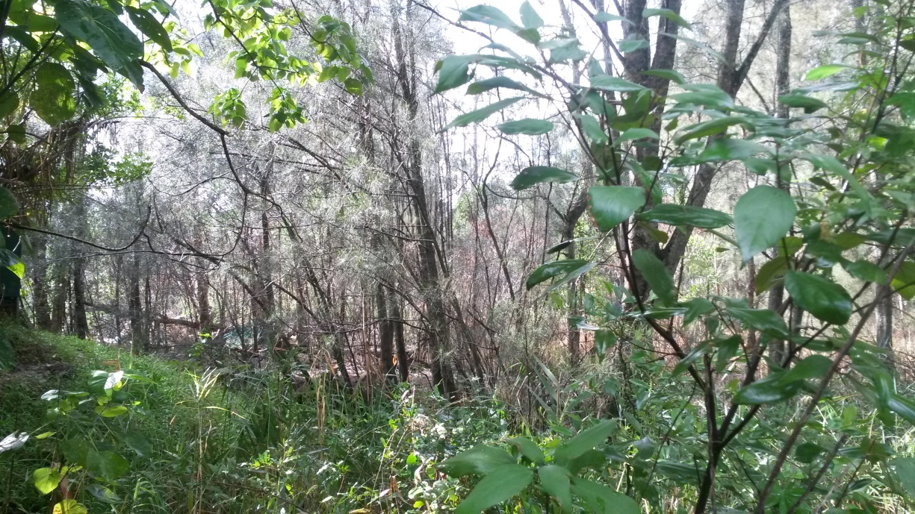
Photo point 1 (Looking North East) April 2014

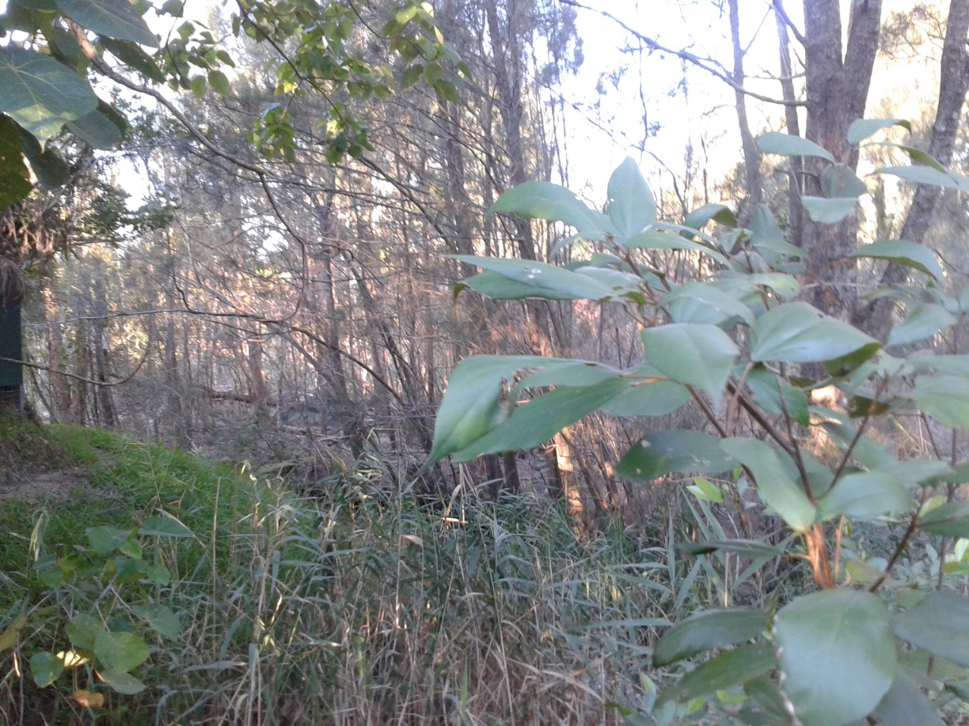
Photo point 1 (Looking North East) May 2014

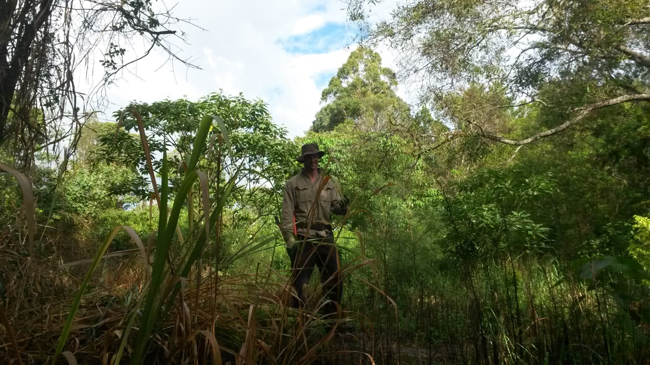
Photo point 1 (Looking South) April 2014

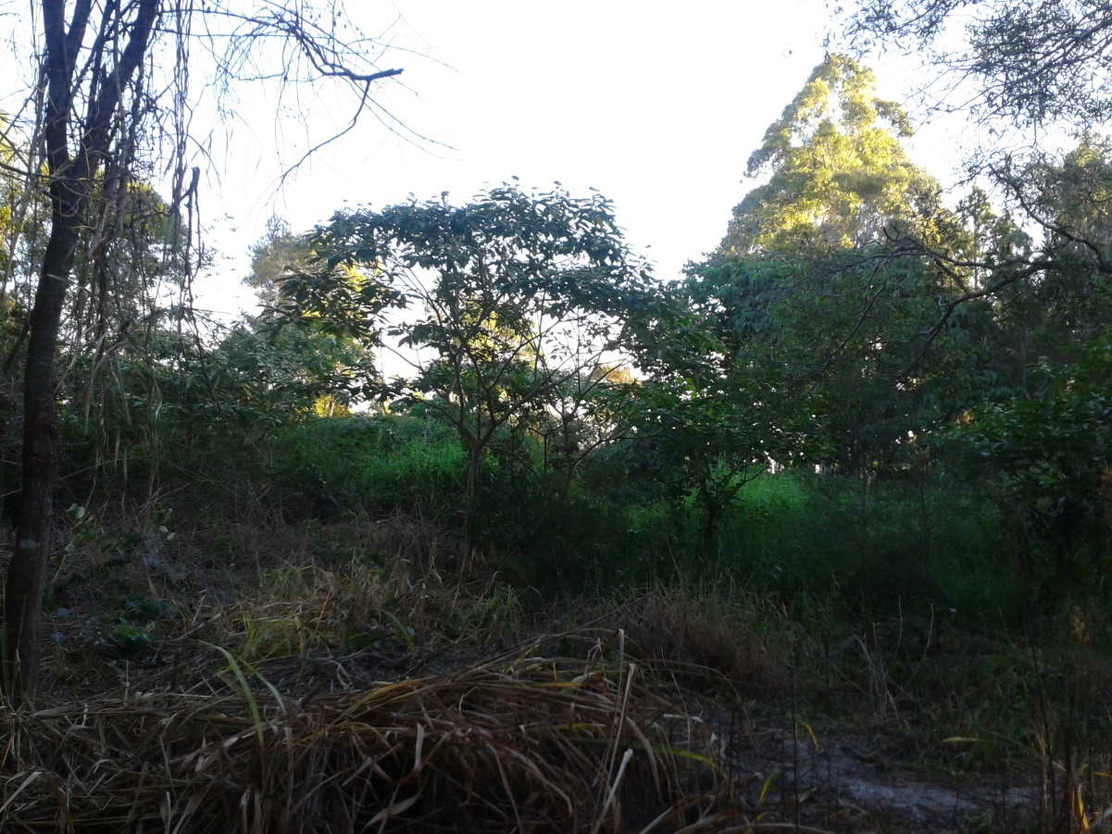
Photo point 1 (Looking South) May 2014

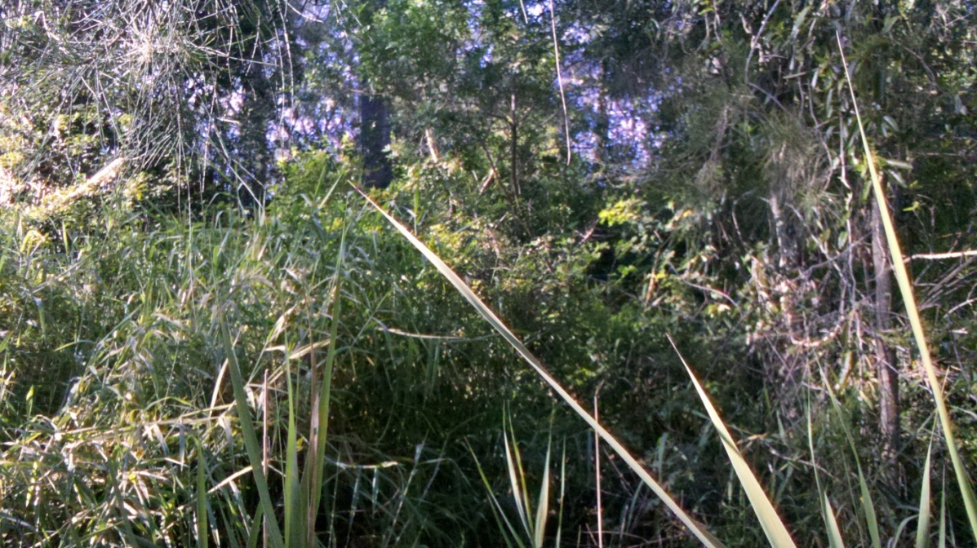
Photo point 2 – February 2014

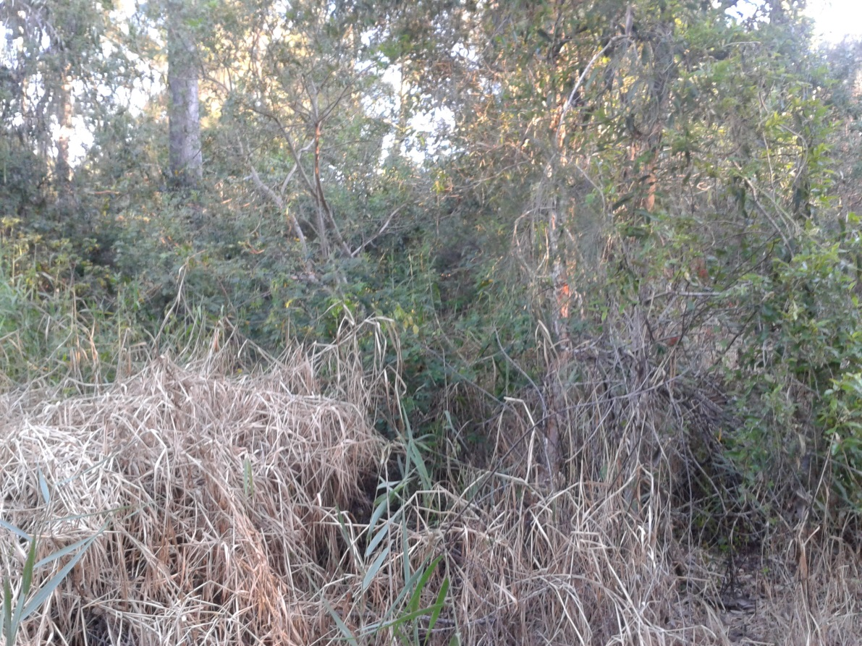
Photo point 2 – May 2014

