Presidents Report FMR AGM 14/11/2015
Firstly, thanks the Di and Paul for the hosting of the meeting at their property at Mongarlowe.
2014/15 has been a relatively quiet period for FMR, allowing people to relax and smell the roses. Certainly the outcomes of the public consultation around the Dargues Reef goldmine and the decision not to pursue cyanide processing at the mine have relieved a lot of local concerns. However, there are likely to still be pressing national, state and local issues that will affect the health of local rivers and catchments, and FMR must maintain its watching brief. The concerns that I expressed last year are all largely still relevant, and the Federal and state governments do not seem to be allocating a high priority to environmental matters. Other issues such as the proposed NSW local government amalgamations (although resisted by Palerang and other local shires) are likely to see changing focus and pressure on environmental programs within shires. Consequently FMR must continue to be vigilant about threats to the river and its biodiversity.
It was pleasing to see high flows in the river again in 2014/15, after so many years of relatively low flows. Hopefully the aquatic biota has responded to these consecutive years of good flow, and we will again see good numbers of native fish, crayfish and platypus in the river in future years.
FMR activities in 2014/15 have included the revamping of the FMR website (thanks Lucy), dealing with invasive ox-eye daisies Leucanthemum vulgare along roadsides and properties, and more social events such as the walk in May to Half Moon and the Sydney Heads to look at the lagoons and old gold workings (Thankyou Sandra for arranging property access).

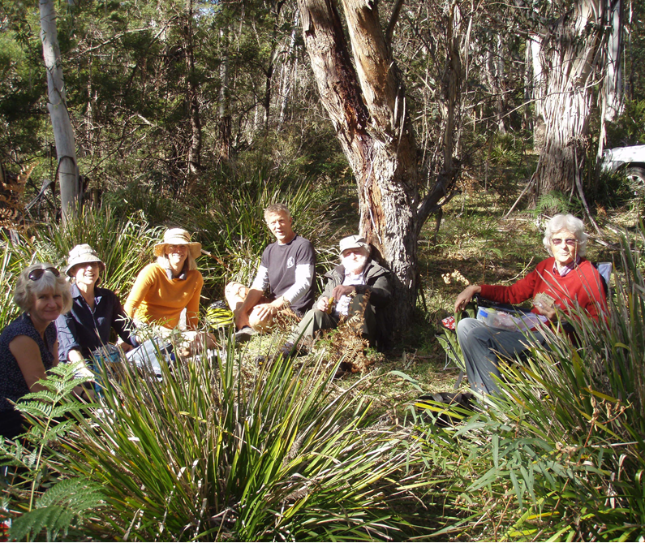
Other activities included a great Mongarlowe River nature walk and plant ID morning, and a visit to the Mongarlowe Landcare Tree Plot run at the Tyndale-Biscoe’s (Thanks Marina and Hugh). There was also the joint FMR/Landcare event where Dr Leigh Martin from the Total Environment Centre gave a talk on issues affecting biodiversity in NSW.
The potential activities that Isuggested last year are still relevant, and maybe in 2015/16 could include:
- Developing a more formal monitoring approach to the Bank Job (see minutes of FMR general meeting of 31/8/2014)
- A downriver canoe trip to look at potential changes since the last downriver escapade of 2008. This could be an event that we run every few years to look at how the river has changed, spread of weeds, etc. It could be the basis for a ‘State of the River’ report/summary, and be compared to the info that we collected in 2008.
- Some fauna and vegetation activities to increase knowledge and appreciation of the natural resources of the Mongarlowe catchment
Also, remember, it is 30th anniversary of FMR in 2016 so let’s think how we can celebrate this milestone.
Unfortunately I can no longer remain as President as Lucy and I have now regretfully sold our property on Northangera Road to be closer to work and family in Canberra, and I have taken on some new work commitments that significantly restrict my capacity for other roles. I intend to still remain active in FMR, just not as the Pres. I would like to thank the FMR committee and office-holders for their continued enthusiasm for the group, and for their assistance to me over the past 2 years that I have been President, and hope that 2015/16 will be a productive and exciting year for FMR
Mark Lintermans
13/11/2015

