“Additional information and membership details can be found on our website or by contacting our Secretary.
Upcoming events including plant identification walks landcare activities and project working bees are updated on our website

.
Contact Information

Secretary:

Friends of The Mongarlowe River Inc.
P.O. Box 175, Braidwood 2622

www.landcare.nsw.gov.au/groups/friends-of-the-mongarlowe-river-inc

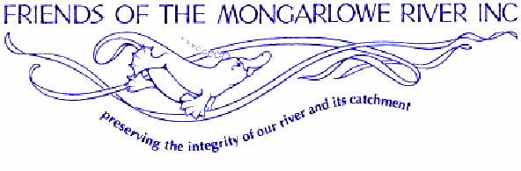

The Friends of Mongarlowe River Inc
Celebrating 30 years.

FMR comprises a diverse group of people who strive to keep the pristine Mongarlowe River and its catchment a lasting legacy for generations to come)

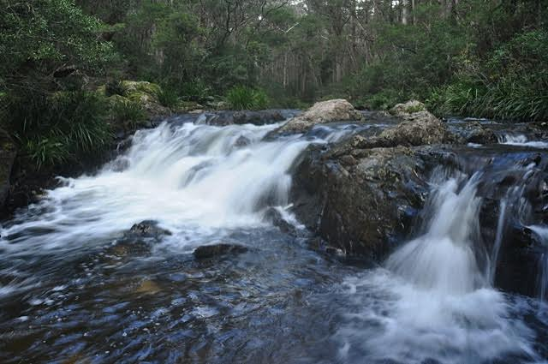

In the late 1990s FMR broadened its activities to include the protection of Monga Forest as a means of ensuring the quality of the river. A reserve proposal was prepared by the group and submitted to Resource and Conservation Assessment Commission. Monga State Forest was included in an interim reserve. In the same year, State Forests planned to log an area in the Monga State Forest which contained old growth.
The Friends were involved in the RFA (Regional Forest Agreement) process from it’s inception in 1998. They commissioned an in depth study of forest values and processes, organized visits by politicians and took many groups into the forest to demonstrate the sheer quality and magic of the place. The RFA decision in January 2000 gazetted some 80% of the former Monga State Forest as National Park. State Forests continued logging in three compartments in Monga. After further campaigning the remaining 20% was protected. Another section that belonged to State Forests north of the Kings Hway following the banks of the Mongarlowe River was also handed over to NPWS with the exception of a section
handed over to Mineral Resources NSW.

FMR Member Activities
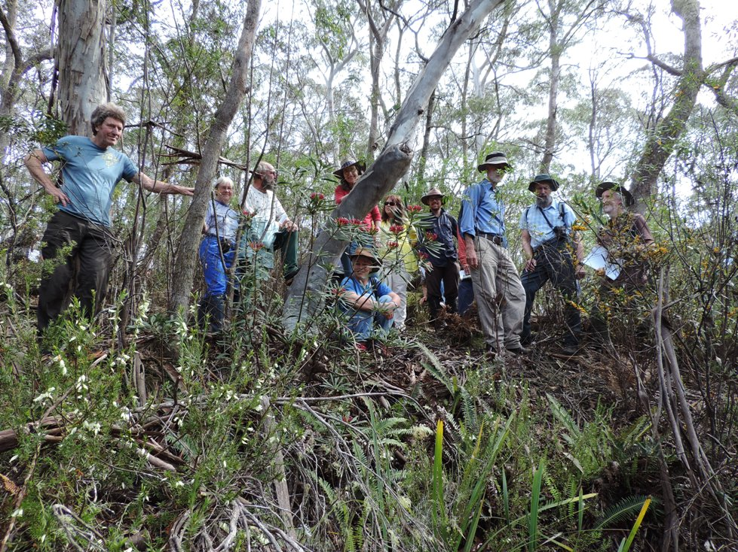

Brief History

Friends of the Mongarlowe River was founded by Judith Wright, in 1986 when a group of residents opposed the plans to rework gold tailings near the Mongarlowe River (Braidwood, NSW). If the proposed activity had taken place, toxic chemicals could have been released into one of the cleanest rivers in the state with grave results for water quality. Fortunately the proposal was dropped.
At a later date FMR also objected about an ill-considered scheme to divert water from the river over the escarpment to supply the coast with water from the Mongarlowe River.
History cont.

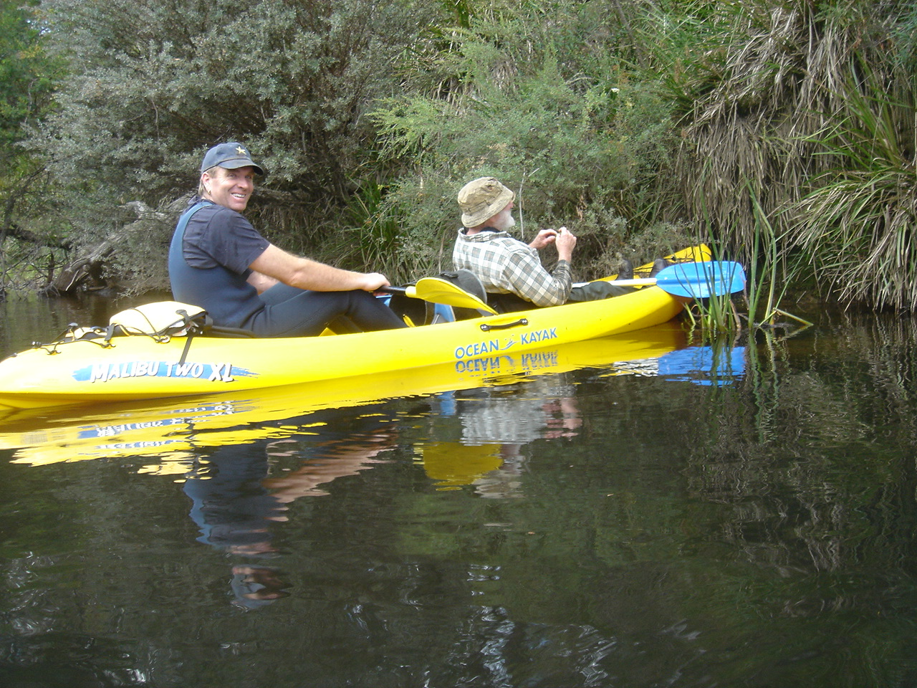
Down Riverr Assessment Mac Perch project
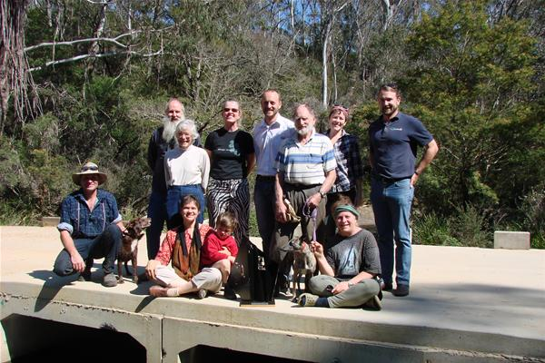
Bringing Back the Fish mob at Burkes Crossing
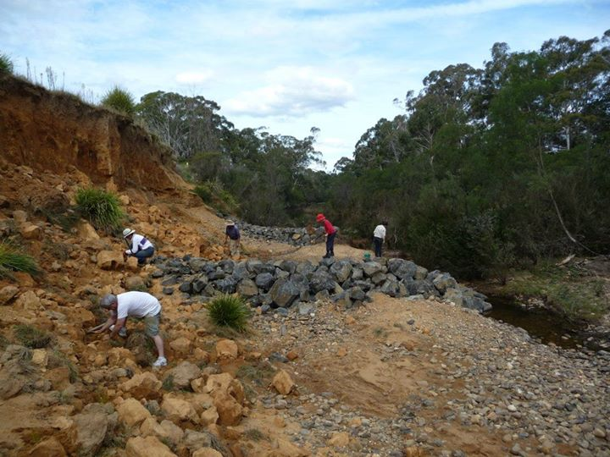 Rehabilitation Bank Job
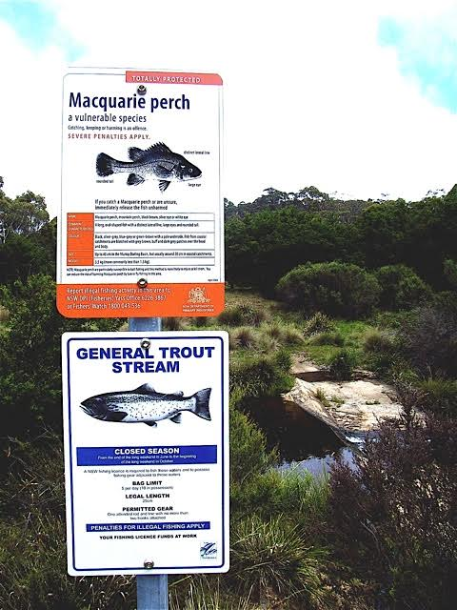
Signage various sites

Recent Activities by members

Macquarie Perch Project
An ongoing project to assess the presence of the now nationally endangered Macquarie perch. The Macquarie perch requires a clean river with clear access across riffles in order to spawn and multiply.

Bringing Back the Fish
In 2008 NSW Department of Primary Industries (fisheries) received funding for river crossings rehabilitation across NSW .Due to the Macca Project, FMR brought to attention the incompatibility of Burke’s crossing, not allowing trouble-free upstream passage for the Macquarie Perch and smaller fish. This Bringing Back the Fish project won the Banksia Award and celebrated with FMR at Burke’s Crossing.

‘The Bank Job’ riverbank rehabilitation.
Following on from the initial Macquarie Perch project a second project was undertaken with NSW Recreational Fishing Trust habitat action grants 2010-2011 to repair and remediate a section of riparian zones along the lower Mongarlowe river.
In 2007 FMR undertook a riparian assessment of the river and noted a severely eroded bank at this site, and so developed ‘The Bank Job’ riverbank rehabilitation.

