NEWS
SEPTEMBER 2018
Rainforest ID every Friday 10 am  Want to know more about rainforest species in our region? We are learning to use a Key Guide to identify trees from their leaves, seeds, fruit, flowers and branches. |  |  | 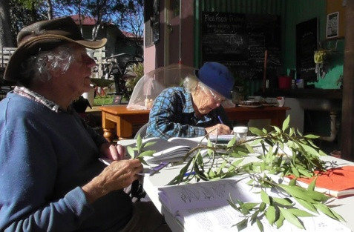
RAINFOREST TREES & SHRUBS  LOCAL NATIVE  PIONEERS  Mon, Wed, Fri & Sat  9:00 am – 12:30  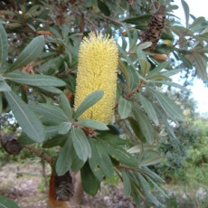  Banksia  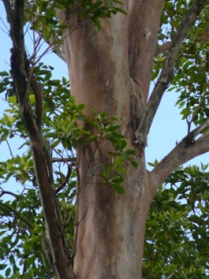  Brush Box  Our website is here  Find us on FACEBOOK  CONTACT:  PH: 02 6657 1189 rdi3@bigpond.com  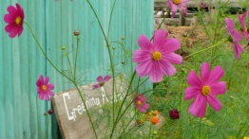  Celebrating one year  DANDARRGA LANDCARE NURSERY  OPEN DAY  is  SEPTEMBER 21st  10am – 2pm  Bring food to share |  | Nursery News  One Year Celebration and Open Day  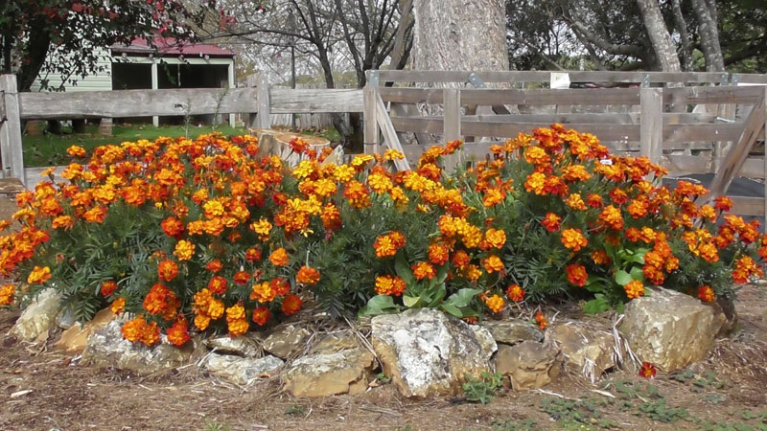  Friday September 21^{st from} 10am – 2pm  We’ve achieved a lot in a year! Come and help us celebrate. Bring friends and family, and food to share.  .  Bush Regen @ Dundurrabin Community Centre  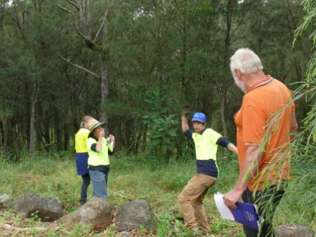  We are having a working bee and picnic lunch at Dundurrabin Community Centre in the first week of October, either Tues 2nd or Thursday 4th from 9am – 3pm.  For more information,  Contact Barry Hicks  0427 857 435 barryhicks54@gmail.com  Look for us at these events:  Dundurrabin Coffee and More Markets  Sunday Oct 13th  DorrigoFolk and Bluegrass Festival Oct 25th – 28th  GARDENING  Landscaping and planting of native and food species is ongoing. Keen gardeners are invited to help rejuvenate the Showground Nursery site, and share their local knowledge and ideas.  DORRIGO SEEDSAVERS held a series of workshops at the nursery this winter. Nyssa held workshops on seed saving, and Joy showed us how to make premium compost and seed-raising mix. We are planting seed of garden vegetables, herbs and food trees, for sale and to plant in our garden beds for seed. New members are welcome, ask at the nursery.  FREE FOOD FRIDAYS –  Dandarrga Landcare Nursery would like to establish a base for excess produce exchange, every Friday morning. No currency involved, and free for all. Bring in your excess produce or we can help and pick up. This is a trial project – based on sharing, and on reducing food waste in our community.  MAKING SOIL  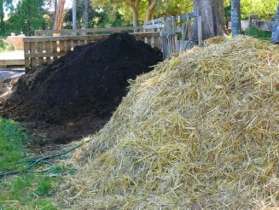  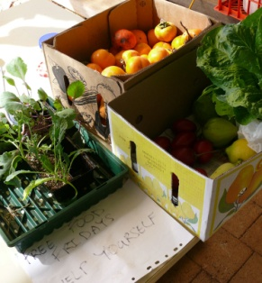  Thanks to Ian and Amanda for the supply of spoiled silage bales, and Reg for all the cow patties, our compost bays and garden beds are busily cooking.  CHECK YOUR SHEDS  We can RE-USE and RECYCLE: Waxed boxes, plastic plant trays, wheelbarrows, hoes, garden ornaments, rocks and water features, compost bins, old feed bags.  VOLUNTEERS are WELCOME to work on our bush regen projects, privet pulling and weeding, species research, grant applications, or hands-on propagation at the nursery.
Bush Regen @ Dundurrabin Community Centre  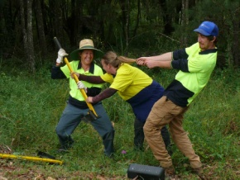  Tuesday & Thursday mornings with Barry  For more information,  Contact Barry Hicks  0427 857 435 barryhicks54@gmail.com  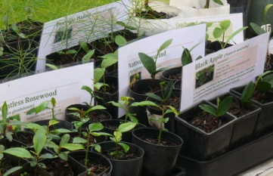  Look for us at MID Market in July |  | Our Local Waterways  Bush Regen projects are underway on some of our local creeks and rivers, to clear invading weeds and restore some of the original biodiversity by planting native trees and shrubs.  Bielsdown River  Weed control and staged planting  Rocky Creek  Weed control team effort, with Mountain Top Landcare, Bellingen Bush Regenerators and Bellingen Shire Council.  Deep Creek  Long term plan for weed control and staged planting  Blicks River  Ongoing weed control and staged planting  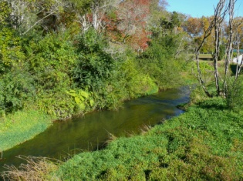  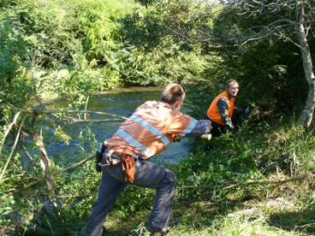  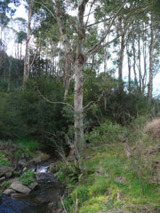  GET INVOLVED  We are 58 paid up members, with an active ‘core’ of about a dozen. There are plenty of activities underway and planned that need people, creativity, enthusiasm and labour.  You can get involved in whatever way suits your skills and free time. Drop in to the Nursery for a cuppa and a chat.  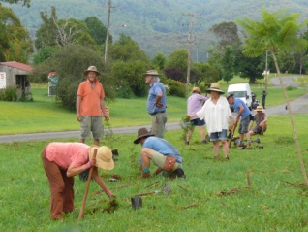  JOIN DANDARRGA LANDCARE  Do you know anyone who’d like to join?  Membership is $10 pa. This covers our volunteers for insurance & for member ‘credits’ on labour and trees.  DOWNLOAD a MEMBERSHIP FORM

