SOUTHERN HIGHLANDS LANDCARE NETWORK INCORPORATED

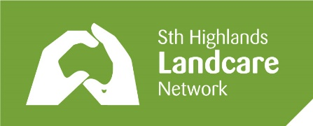

A non-profit organisation
ABN 42056929755

c/- Secretary, P.O. BOX 1193, BOWRAL, NSW 2576

Email Membership Officer: Kerri Burke member.finance@shln.org.au

MEMBERSHIP APPLICATION or RENEWAL

I,

support the aims and activities of the Southern Highlands Landcare Network to manage and protect our precious natural environment, and wish to become, or renew, as a member

for the financial year of 2025-2026.

Signature: Date:

CONTACT DETAILS

Mobile:

Email:

FEES (per financial year)

Individual: $10

Landholders: $50

Donation:

PAYMENT Bendigo Bank BSB 633 000 Acct 200093227

- Online transfer, or

- In person at Moss Vale, Bowral or Mittagong

When making your payment in person, please ask that your surname is attached to the payment.

When making the payment online, please include your surname as the description.

