**SOUTHERN HIGHLANDS LANDCARE NETWORK INCORPORATED**

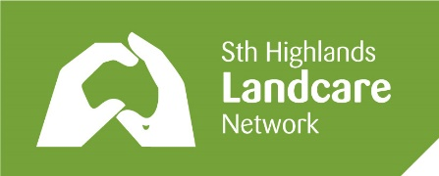

A non-profit organisation

**ABN 42056929755**

c/- Secretary, P.O. BOX 1193, BOWRAL, NSW 2576

Email Membership Officer: Kerri Burke member.finance@shln.org.au

**MEMBERSHIP APPLICATION or RENEWAL**

**I,**

support the aims and activities of the Southern Highlands Landcare Network to manage and protect our precious natural environment and wish to become, or renew, as a member

**for the financial year of 2024-2025.**

**Signature: Date:**

**CONTACT DETAILS**

**Mobile:**

**Email:**

**FEES** (per financial year)

**Individual: $10**

**Landholders: $50**

**Donation:**

**PAYMENT Bendigo Bank** BSB 633 000 Acct 200093227

* **Online transfer, or**
* **In person at Moss Vale, Bowral or Mittagong**

When making your payment in person, please ask that your surname is attached to the payment.

When making the payment online, please include your surname as the description.